Benha University  Faculty of Engineering at Shoubra  Electrical Engineering Department  1st Year Communications |  | Final Term Exam  Date: Sunday 24/1/2016  Subject: Electrical Circuits 1  Duration: 3 hours
- Answer all the following questions  - Illustrate your answers with sketches when necessary |  | - No. of questions : 2 in Part II  - Total Mark: 45 Marks for Part II
Part II
[45 Marks]
Answer the following questions:

Question (4) [23 Mark]:
- A sine wave has a frequency of 100 kHz. How many cycles does it complete in 10 ms? [3 Marks]
- A series RL circuit has a resistance of 20kΩ and a coil of 10 mH at a frequency of 10 kHz. Determine the total impedance and phase angle. [4 Marks]
- Determine the instantaneous value at the 90º reference point on the horizontal axis for each wave in the following figure [6 Marks]

- Compare between active and passive filters. [4 Marks]
- Compare between low pass, high pass, band pass and band stop filters. [6 Marks]

Question (5) [22 Mark]:

- Use transformation theorems (i.e. Norton or Thévenin) (Note: you must Mention to the applied theory in your answer) to calculate: [11 Mark]
- The current through R2 and L2.
- The voltage drop across R2.
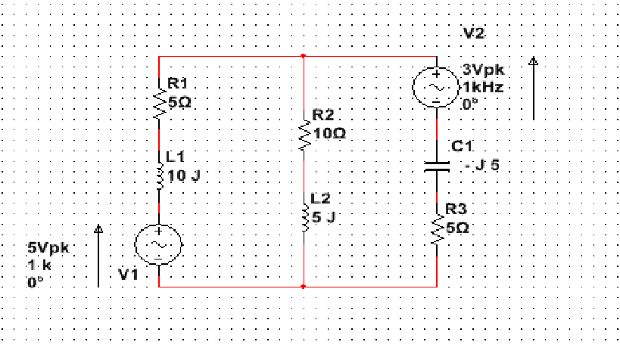

- Apply circuit theory techniques (i.e. Mesh or Nodal) to solve the following problem

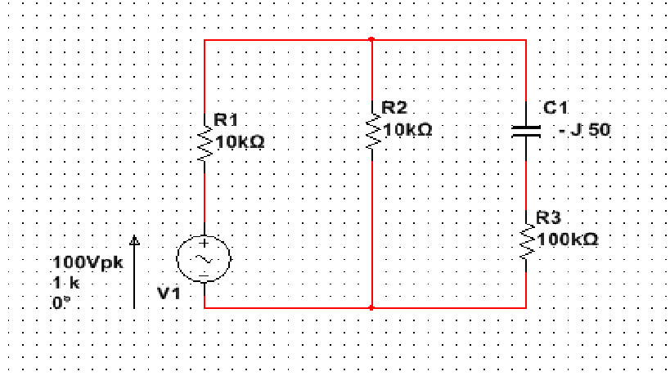

Assume that the above circuit is a part from television receiver circuit and the branch (C1 and R3) is a critical part and we need to know:
- The rated power for R3 to be used.
- The rated voltage for C1 to be used, to ensure normal operation for long time without the receiver gets damaged.

Good luck
Dr .Michael Nasief

